**CAPTURING SOULS**

SOCIAL ENTERTAINMENT APPLICATION

**PREPARED BY**

JOSHI DEV (196250307026)

VADGAMA SUJAL (196250307069)



**GOVERNMENT POLYTECHNIC, JAMNAGAR**

COMPUTER ENGINEERING (2021-22)

# Capturing Souls

**A PROJECT REPORT**

**SUBMITTED BY**

Joshi Dev (196250307026)

Vadgama Sujal (196250307069)

**In fulfillment for the award of the degree of**

**Diploma Engineering in**

**Computer**



**Gujarat Technological University, Ahmedabad**

**Government Polytechnic, Jamnagar Computer Engineering**

**(2022)**

**CERTIFICATE**

**DATE: 04/06/2022**

This is to certify that the dissertation entitled **“Capturing Souls”** has been carried out by **JOSHI DEV, VADGAMA SUJAL** under my guidance in fulfillment of the degree of Diploma Engineering in Computer (6th Semester) of Gujarat Technological University, Ahmedabad during the academic year 2019-2022.

**INTERNAL GUIDE HEAD OF THE DEPARTMENT**

Mayuri Bhalodiya Kaushal M. Shah

**ACKNOWLEDGEMENT**

Under circumstance where receiving education to develop a huge project such as this, the journey has been quite challenging but it is an important lesson to learn. This project has brought all the concepts that we have learned previously in academic years together and brought some clarity and experience.

As a team our efforts for development has effective, as a result this project is at its finest condition.

- JOSHI DEV

**ABSTRACT**

Successful photographers from around the world are discovered by submitting their work to photo contests. Magazine editors, gallerists, curators, book publishers, festivals directors and photo agencies are always eager to discover new talents that are highlighted by major competitions.

Our photo competitions were created so that photographers from any level can express their talent and let the whole world discover their most beautiful images. All About Photo thrives to feature the best projects and gives photographers visibility on an international level. Our renowned jurors endorse talent and creativity. Here you can discover the winners and other highly-rated submissions from each photo competition.

Photography contests are a great way to find out if your images are up to scratch.

Table of Contents

Capturing Souls 2

1. INTRODUCTION 6

1.1 PURPOSE 7

1.2 INTRODUCTION TO SYSTEM 7

1.3 SCOPE 7

1.4 EXISTING SYSTEM REVIEW 7

1.5 PROPOSED SYSTEM 8

1.6 SOFTWARE DEVELOPMENT PROCESS MODEL 8

2. SOFTWARE REQUIREMENTS SPECIFICATION 9

2.1 USER CHARACTERISTICS 9

2.2 FUNCTIONAL REQUIREMENTS 10

2.3 EXTERNAL INTERFACE REQUIREMENTS 12

2.4 NON-FUNCTIONAL REQUIREMENTS 13

3. SYSTEM ANALYSIS AND MODELING 13

3.1 FEASIBILITY STUDY 13

3.2 USE-BASED MODELING 15

4. SYSTEM DESIGN 19

4.1 DATA MODELING 19

4.2 BEHAVIORAL MODELING 21

4.2.1 ACTIVITY DIAGRAM 21

5. USER INTERFACE DESIGN 22

5.1 SAMPLE UI DESIGN 22

5.2 SAMPLE CODE 24

## 1. INTRODUCTION

This document is a project report for a Photography contest website which held photography competition every week. Our photo competitions were created so that photographers from any level can express their talent and let the whole world discover their most beautiful images. All About Photo thrives to feature the best projects and gives photographers visibility on an international level. Our renowned jurors endorse talent and creativity. Here you can discover the winners and other highly-rated submissions from each photo competition.

### 1.1 PURPOSE

This document is essential to keep activities related to this project in check as this project evolves and turns into a software product. The purpose of this document is to provide complete details about this system can be developed.

### 1.2 INTRODUCTION TO SYSTEM

In a Social Entertainment Platform various type of fun or entertaining related content revolves around a wide community of users. The content could be photograph, location etc. All of the content is provided by either individual person or a team of individuals working on numerous contents. The content could be tiny pieces of information or large courses. Users who wish to get fame and learn better skills can engage with content and post it in such a platform.

This platform particular deals with posting photograph and observing others post to improve skills and to get knowledge about what’s new in market.

### 1.3 SCOPE

The system is called Capturing Souls. It is basically a social network for entertainment purposes that connects professional photographers and the beginner through the contest between them. The users can upload their picture into the contest (no matter whoever it is i.e. either professional photographer or a common man) with the location where the picture would be captured. Then the team of Juries being handled by administrators, decides which picture/post is capable of getting 1st,2nd,3rd positions.

Beginners are the users which shall use the system to learn more about photography and improving skills by watching the photography skills of well photographer(s).

Professional photographer are the kind of users which shall use system to get knowledge about what’s new to the market. The content that they upload may inspire other participants like beginners and e self-learner by getting their points of drawback (lack of specific skill).

### 1.4 EXISTING SYSTEM REVIEW

System that provides facility of contest unevenly held on any month or a week. A specific day or date are not provided, it holds on a user request where the limitations and venue are decided by users too. The winners are decided by draws of like the user get on their post/picture. No juries are presented to decides the winner.

### 1.5 PROPOSED SYSTEM

This system would provide facility of contest holding every week. The starting day/date and a pre-decided deadline would be provided before which user have to upload their picture/post. 2 days before ending week, the content would be open for every user to surf through other participant’s post.

This system would provide a team of professional Juries, which provides the winners 1st 2nd 3rd accordingly. So here a physical person is attended to decide the winner.

### 1.6 SOFTWARE DEVELOPMENT PROCESS MODEL

A software development process is the method of dividing development work into different phases to build a good quality software. Various models are used for different kinds of software. A well-suited model improves in quality, design and management of the software and also conserves the time taken to build the software.

6.1 Prototype Model

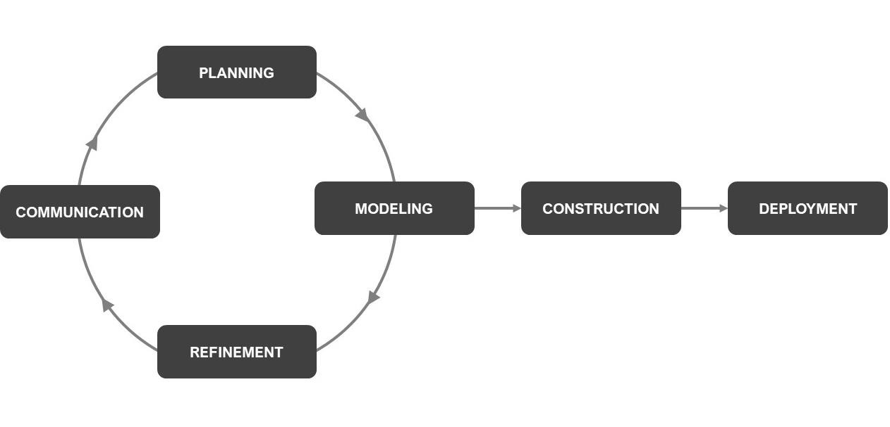

*Figure 1.6.1: Prototype Model*

**Why is Prototype Model suitable for this system?**

Reason for choosing Prototype model is an understaffed team and lack of experience. Prototype model is an efficient approach towards development of this system because it is suitable for phases where constant changes and modification occurs. Construction of the system could safely start once all the refinements and modeling is at its end without any setbacks. Even a small and less experienced team can keep all the phases in check and develop a decent quality software.

## 2. SOFTWARE REQUIREMENTS SPECIFICATION

A Software Requirement Specification (SRS) is a documentation that describes requirements and functionality of the system.

### 2.1 USER CHARACTERISTICS

#### 2.1.1 Mode 1: Visitor

Visitor shall be allowed to use limited functions of the system without being an authorized user of the system. A visitor would only be allowed to browse the content of the system and like the post(s).

#### 2.1.2 Mode 2: Standard User

Once Visitor registers to the system, he/she becomes Standard User to the system. Standard User would be able to access all the functions of the system.

Standard User module includes...

* Browse the content
* Like Post
* Upload /Post a picture
* Can be a winner

#### 2.1.3 Mode 3: Administrator

Administrator is a special kind of user whose responsibility is to manage the data of the system. Administrator could be more than one, depending in the requirements of the system. There are various types of Administrators such as Database Administrator, Data Administrator and more.

Functions of Administrator module includes…

* Manage users
* Make changes to data (such as Database schema, UI changes and updates)
* Manage flagged content
* Analyze and solve errors
* Develop content on behalf of the organization (system)

#### 2.1.4 Mode 4: Developer

Developer is a kind of user who create the contest(competition) with certain information and uploads it on the system. Developer is also the one of juries’ teams who decides the winner of contest.

Function of developer are…

* To browse the content of system
* Uploads the contest with requirements and information regarding it.
* And to decide the winner and give 1st 2nd and 3rd position to participant.

### 2.2 FUNCTIONAL REQUIREMENTS

Functional requirements define all the functions of a system or its components. Below, all the functionalities are categorized based on the type of user allowed to access. Functions are classified for three different types of users, Guest, Standard and Administrator. Each function has its description and functional requirements below it.

#### 2.2.1 Visitor

##### 2.2.1.1 Browse

This function shall allow user to browse and go through contents of the system such as post without registering as a Standard User. Visitor shall be able to only browse the content.

**FUNCTION:** To enable Visitor to go through the content of system i.e. contest photos.

**INPUT:** Visitors shall visit the post on the home page.

**PROCESS:** The system shall display the contents of respected page

**OUTPUT:** Visitor shall be able to view desired content.

##### 2.2.1.2 Like post

This function shall allow user to browse and go through contents of the system such as liking a post without registering as a Standard User. Visitor shall be able to only like the post.

**FUNCTION:** To enable Visitor to like the photograph of contest.

**INPUT:** Visitors shall like the post on the home page.

**PROCESS:** The system shall display the contents of respected page

**OUTPUT:** Visitor shall be able to view desired content.

#### 2.2.2 Standard User

##### 2.2.2.1 Register

This function shall allow user to sign up into the system. To create an account user must have an E-mail Address. User shall provide registration details such as First Name, Last Name, E-mail Address, Username and Password. The system shall check given information to verify authenticity of the information and as all the details are verified the system shall register the user create a new user account.

**FUNCTION:** To enable visitor to create account.

**INPUT:** New user shall provide registration information.

**PROCESS:** The system shall verify provided information.

**OUTPUT:** New account shall be created.

##### 2.2.2.2 Log in

This function shall allow user to enter into the system by verifying his/her Username or Email address and Password. User must have an account already created in the system to login. After providing Username or E-mail Address and Password the system shall check login information and if the user already has an account, then user shall be allowed to enter in the system else an error message shall be prompted to user.

**FUNCTION:** To enable Standard User to enter/login into the system.

**INPUT:** User shall provide login credentials.

**PROCESS:** The system shall verify provided credentials.

**OUTPUT:** User shall enter the system as a Standard User.

##### 2.2.2.3 Like post

This function shall allow user to browse and go through contents of the system such as liking a post after registering as a Standard User.

**FUNCTION:** To enable User to like the photograph of contest.

**INPUT:** User shall like the post on the home page.

**PROCESS:** The system shall display the contents of respected page

**OUTPUT:** User shall be able to view desired content.

##### 2.2.2.4 Upload Post

This function allows User to upload post/picture into the contest as a participant. Standard user can only upload post/picture after his/her registration. User shall add location addressing the place where the uploaded picture is captured.

**FUNCTION:** To enable user to upload picture/post into the contest as a participant.

**INPUT:** User shall select one picture and add location.

**PROCESS:** The system shall store uploaded photo and location.

**OUTPUT:** User shall be shown that his/her picture is successfully gets uploaded on the contest

#### 2.2.3 Administrator

##### 2.2.3.1 Log in

This function shall allow administrator to enter into the system by verifying his/hers Username or E-mail address and Password. Administrator must have an existing account created by the System Administrator to login. After providing Username or E-mail Address and Password the system shall check login information and if the credentials are current then user shall be allowed to enter in the system else an error message shall be prompted to user.

**FUNCTION:** To enable Administrator to enter/login into the system.

**INPUT:** User shall provide login credentials.

**PROCESS:** The system shall verify provided credentials.

**OUTPUT:** User shall enter the system as Administrator.

##### 2.2.3.4 Content Validation

Content of each kind must be validated for false or inappropriate portions before uploading to every user to prevent miseducation. It shall be Data Administrator’s duty to review and take action against content that is either not validated correctly or is flagged by users.

**FUNCTION:** To enable administrator to review and take action against foul content.

**INPUT:** The administrator shall browse or shall be notified by the system for foul picture or information. Administrator shall choose an action for foul content.

**PROCESS:** The system shall take administrator instructed action on content notify the user responsible and wait for user to change the content.

**OUTPUT:** Updated foul content shall be reviewed by administrator and the content shall be back in its previous state.

#### 2.2.4 Developer

##### 2.2.4.1 Post Contest

This function allows the Developer to upload/post/start a contest on which a participant(user) will upload his/her photo to clash against each other to win.

**FUNCTION:** To enable Developer(juries) to upload/post/start a the contest.

**INPUT:** Developer shall provide deadline, format of photograph and photo criteria according to the decided week.

**PROCESS:** The system uploads the contest with deadline, format of photograph and criteria.

**OUTPUT:** The contest shall be published on the contest page with deadline, format and criteria of photograph.

##### 2.2.4.2 Decides winner

The Developer decides the winner after surveying all the photographs uploaded by participant. Developer (juries) checks the photo by comparing with criteria and format & location.

**FUNCTION:** To enable Developer to select posts from the system.

**INPUT:** Developer shall provide winner’s name, photograph, location of photograph and position in the contest

**PROCESS:** The system store data of contents and awaits administrator’s action.

**OUTPUT:** On successful validation, results shall be available for every user.

### 2.3 EXTERNAL INTERFACE REQUIREMENTS

#### 2.3.1 Hardware Interface Requirements

The system runs over the internet. Whatever the device, computer or mobile requires internet connection. Hardware shall require internet connection capabilities through network devices such as Modem, Wi-Fi, Ethernet, etc.

#### 2.3.2 Software Interface Requirements

The system shall run on servers accessed via internet. Servers requires several types of Server-Side Scripting Languages to manipulate data and Database to store those data and software to manage database. At the Client-Side a web browser is required to interact with the system.

### 2.4 NON-FUNCTIONAL REQUIREMENTS

#### 2.4.1 Reliability

The system provides consistent database for data storage and software for periodic backup and recovery. Sensitive data will be stored encrypted and only be access by authorized user.

#### 2.4.2 Portability

The system should be implemented using markup and scripting language to make it available for as both web application to access via web browser and mobile application to access via mobile devices. The system should be compatible with all kinds of platforms and should be available for every software version.

#### 2.4.3 Availability

The system should be available and accessible at all times. User should be able to access and interact with the system using web browser. The system requires 24x7 availability.

#### 2.4.4 Security

This system must keep all the user information confidential and must store in a secure manner. Sensitive data should be encrypted before being sent over to networks.

#### 2.4.5 Maintainability

The Database software and maintenance application prevents information in case of power failure with server application ensuring data recovery maintenance can be done efficiently.

## 3. SYSTEM ANALYSIS AND MODELING

### 3.1 FEASIBILITY STUDY

#### 3.1.1 Technical Feasibility

The proposed system requires variety of technologies in order to be developed in a flawless manner. To access the functions of this system user shall have access to either a computer of average quality or a mobile device.

At the front-end side (user end) for computer devices this system shall be available as a website developed in coding languages such as, HTML, CSS, JavaScript (Here, along with the conventional JavaScript, a JavaScript library called jQuery shall be use in order to reduce substantial amount of JavaScript code). Website shall run on a web-browser of user’s choice. An additional JavaScript library called Vibrant.JS shall be used to improve User Interface by classifying colors for different content. For mobile devices this system shall be available through web-browser as well as an application available to install from the website.

At the back-end (system end) of the system shall be developed various mechanisms using server-side language such as PHP, in order to provide content to the front-end side. The system shall run on an Apache server supporting MySQL with phpMyAdmin interface for database operations. These operations shall be available to use for both computer devices and mobile devices. For mobile device application for platforms such as Android, this system can be developed using Android Studio. Combining the technologies mentioned above this system can provide an easy-to-use interface at frontend and a robust and secure mechanism at the back-end.

A single computer with capabilities to support technologies mentioned above can turn the ideas of this system into a good quality software, thus the proposed system is technically feasible.

#### 3.1.2 Operational Feasibility

The system shall provide an elegant and easy interface for users to comprehend its features. To operate this system front-end user does not have to be a technical person. The system shall be available to use for computer users as well as mobile users. Person with minimal knowledge of computers or mobile devices (such as to access web and use website) can operate the system and its features without any problem.

Back-end users such as administrators require to have technical knowledge such as performing client-side and server-side programming, database operations to maintain the system operability and security for front-end users.

#### 3.1.3 Economic Feasibility

Minimal hardware to access the system are a computer with average specification such as with 2GB RAM, Processor of minimal 1.90 GHz speed, capability to connect to internet using network interface card or Wi-Fi connection or an average quality mobile device capable enough to access internet.

Technologies required to develop this system into a software are available on the internet free of cost thus a single average quality computer device with technologies mentioned above can develop this system and prepare it to publish to the internet.

To make it available to access for end-users this system as a website can be hosted on the web via a trusted hosting company either free of cost or with minimal cost depending on the hosting company. Mobile application of this system can be made available to download from website or via a digital distribution service such as Play Store or App Store to make it available to suitable mobile devices.

From an economical point of view this system is decently feasible and affordable to develop and deliver.

### 3.2 USE-BASED MODELING

**3.2.1 USE CASES**

#### Use Case 01: User

|  |  |
| --- | --- |
| **TITLE** | Create Account /login |
| **DECRIPTION** | This use case describes the steps in creating new user account into the system based on the registrations data provided the user. |
| **ACTORS** | User |
| **PRE-CONDITIONS** | 1. The user is at the home page of the system. 2. The user must have a valid Email address. |
| **NORMAL**  **SCEQUENCE** | 1. User opens registration form. 2. User types first name and last name. 3. User types username. 4. User types email address. 5. User types password. 6. User presses Submit button. 7. System validates registration details. 8. System stores registration details. 9. User is redirected to Dashboard page. |
| **ALTERNATE SEQUENCE** | AS2. System shows “Invalid First Name or Last Name” error. 1. User types valid First Name or Last Name 2. Normal sequence continues from step 3.    AS3. System shows “Username not valid” or “Username already taken” error.   1. User types different/valid username. 2. Normal sequence continues from step 4.     AS4. System shows “Email not valid” error.   1. User types valid email address. 2. Normal sequence continues from step 5.     AS5. System shows “Password not valid” error.   1. User types valid password. 2. Normal sequence continues from step 6. |
| **POST-CONDITIONS** | System will store registration data. |

#### Use Case 02: Like post

|  |  |
| --- | --- |
| **TITLE** | Like other’s post |
| **DECRIPTION** | This use case describes about liking the post on application uploaded by another user. |
| **ACTORS** | Standard User |
| **PRE-CONDITIONS** | 1. The user is at the home page of the system. 2. The user must have a user account. |
| **NORMAL**  **SCEQUENCE** | 1. User opens login form. 2. User types username/email address and password 3. User presses Submit button. 4. System validates login credentials. 5. User is redirected to Dashboard page. 6. User likes the post |
| **ALTERNATE SEQUENCE** | AS2. System shows “Invalid Username/Email” error.   1. User types valid username or email address. 2. Normal sequence continues from step 3.     AS2. System shows “Invalid Password” error.   1. User types valid password. 2. Normal sequence continues from step 3.     AS4. System shows “Account does not exist” error.  User types username/email address of an existing account.  Normal sequence continues from step 3. |
| **POST-CONDITIONS** | User can like the post. |

#### Use Case 03: User uploads the photo for the contest.

|  |  |
| --- | --- |
| **TITLE** | Uploads the picture |
| **DECRIPTION** | This use case describes the steps for standard user to upload picture in the contest |
| **ACTORS** | Standard User |
| **PRE-CONDITIONS** | 1. The user is at the home page of the system. 2. The user must be a registered user. 3. The user’s previous step should be login. |
| **NORMAL**  **SCEQUENCE** | 1. System shows a new tab for uploading picture . 2. User selects the picture he/she wants to upload. 3. User enters the location where the picture is captured. 4. System stores Picture and location uploaded into through content. |
| **ALTERNATE SEQUENCE** | AS2. System shows “Not proper format” error.   1. User selects proper format for picture 2. Normal sequence continues from step 3. |
| **POST-CONDITIONS** | System will store picture and location and redirect to homepage. |

#### Use Case 04: Post Contest

|  |  |
| --- | --- |
| **TITLE** | Post Contest |
| **DECRIPTION** | This use case describes the steps in posting Contest. |
| **ACTORS** | Developer |
| **PRE-CONDITIONS** | 1. The user must be Developer. 2. The developer is must be registered. |
| **NORMAL**  **SCEQUENCE** | 1. At the dashboard developer goes to Contest panel. 2. Developer selects Contest to post. 3. Developer enters format, criteria and deadline for the contest. 4. Developer presses post button. 5. System validates the details. 6. Developer is shown acknowledgment message. |
| **ALTERNATE SEQUENCE** | AS3. System shows “Details missing” error.   1. Developer enters proper details 2. Normal sequence continues from step 4. |
| **POST-CONDITIONS** | System will store posted contest and send for verification. |

**3.2.2 USE CASE DIAGRAMS**

#### 01. USE CASE 01

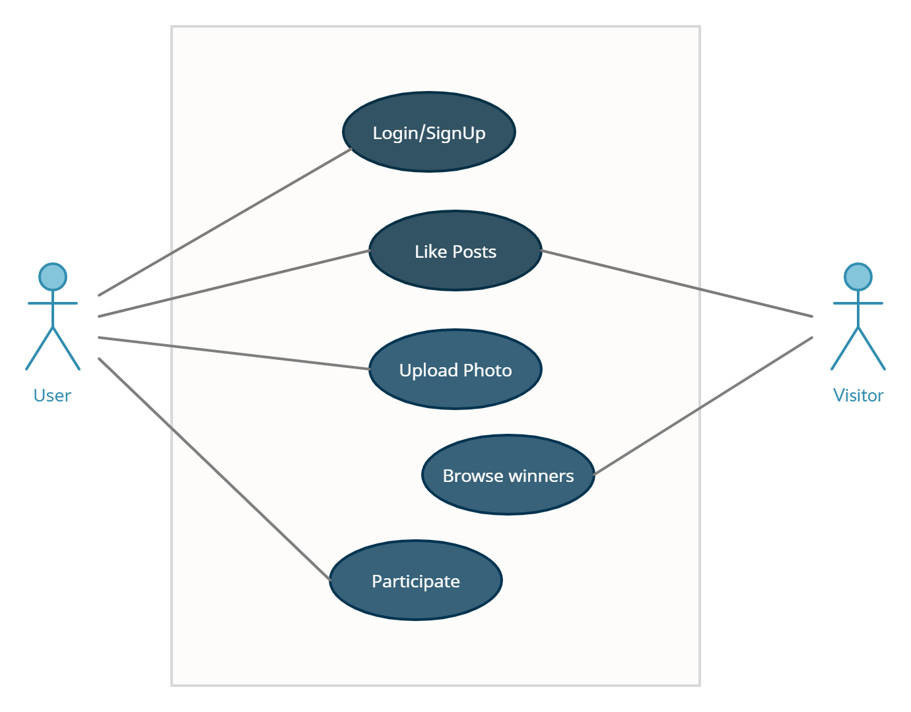

#### 02. USE CASE 02

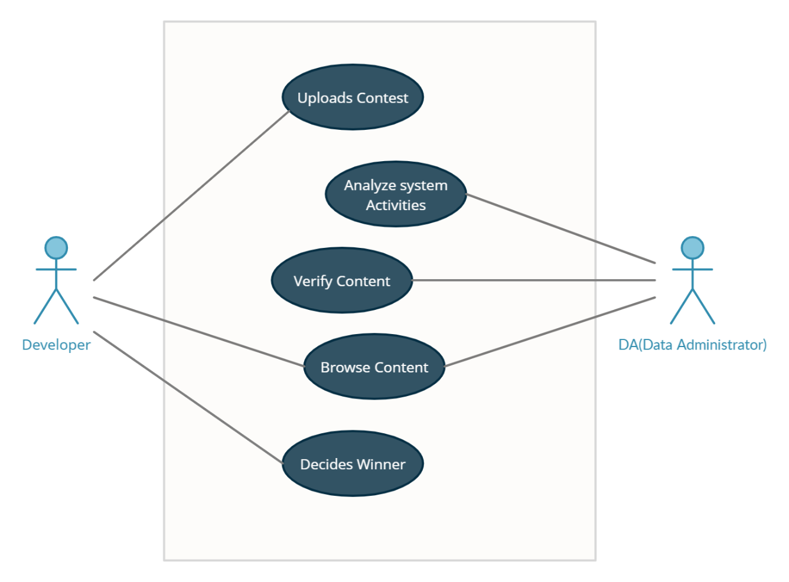

## 4. SYSTEM DESIGN

This section describes concepts related to store and manipulate data related to the system and all the modules of the system.

### 4.1 DATA MODELING

#### 4.1.1 DATA DICTIONARY

All the table that are required in order to store user and system data are shown below. These tables determine columns, size of the data it shall occupy into the database once stored and various database constraints to preserve the consistency of data and description of the data that the tables shall hold.

Table name: User Registration

|  |  |  |  |  |
| --- | --- | --- | --- | --- |
| **Field name** | **Datatype** | **Size** | **Description** | **Key** |
| User_ID | Varchar | 7 | User ID name | Primary Key |
| Name | Char | 25 | Name of User | Foreign Key |
| Password | Password | 10 | Password to Login | Null |
| Phone | Integer | 10 | User phone number | Null |
| Address | Varchar | 50 | User address | Null |
| City | Varchar | 20 | User city name | Null |
| Email | Email | 20 | User email id | Null |

Table name: User Login

|  |  |  |  |  |
| --- | --- | --- | --- | --- |
| **Field name** | **Datatype** | **Size** | **Description** | **Key** |
| User_ID | Varchar | 7 | User ID | Foreign Key |
| Password | Password | 10 | User Password | Foreign Key |

Table name: Upload Picture

|  |  |  |  |  |
| --- | --- | --- | --- | --- |
| **Field name** | **Datatype** | **Size** | **Description** | **Key** |
| Photo_ID | Varchar | 7 | Photo ID | Primary Key |
| Location | Varchar | 25 | Location where picture is captured | Null |
| Device | Varchar | 20 | Device that captured the picture | Null |

Table name: Admin Login

|  |  |  |  |  |
| --- | --- | --- | --- | --- |
| **Field name** | **Datatype** | **Size** | **Description** | **Key** |
| Admin_ID | Integer | 7 | Admin ID | Primary Key |
| Admin_Password | Password | 10 | Admin Password | Null |

Table name: Developer Login

|  |  |  |  |  |
| --- | --- | --- | --- | --- |
| **Field name** | **Datatype** | **Size** | **Description** | **Key** |
| Developer_ID | Integer | 7 | Developer ID | Primary Key |
| Developer_Password | Password | 10 | Developer Password | Null |

### 4.2 BEHAVIORAL MODELING

### **4.2**.**1** **ACTIVITY DIAGRAM**

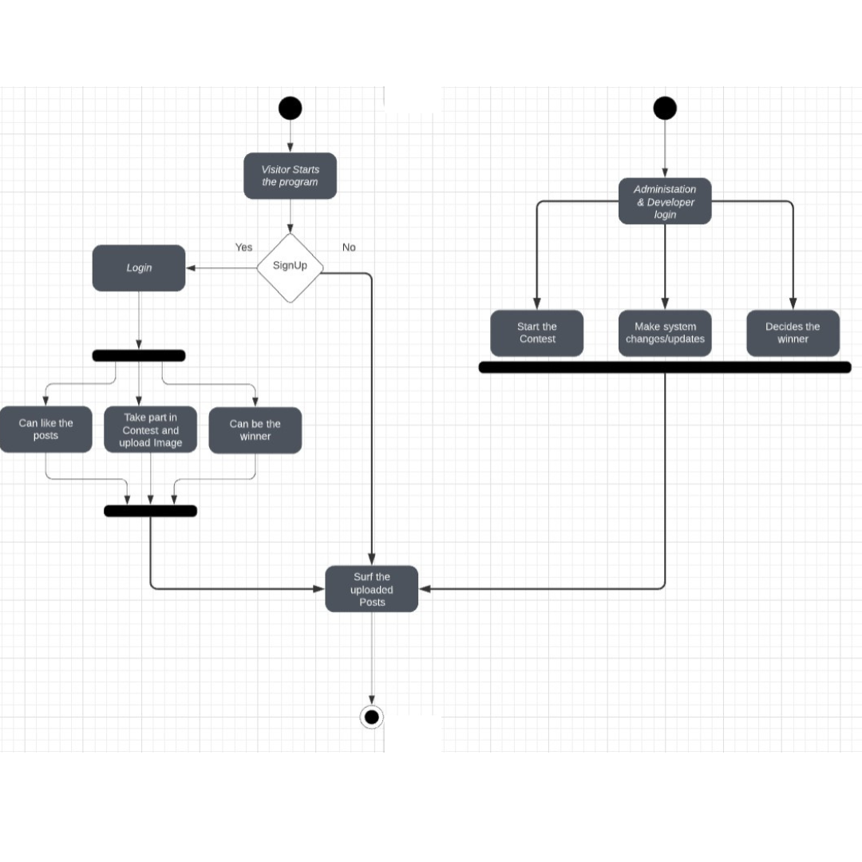

## 5. USER INTERFACE DESIGN

### 5.1 SAMPLE UI DESIGN

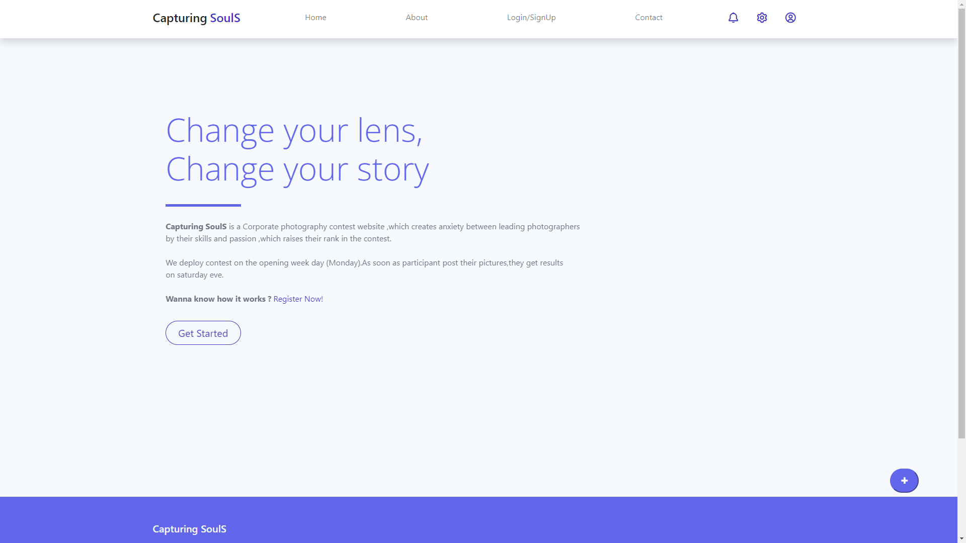

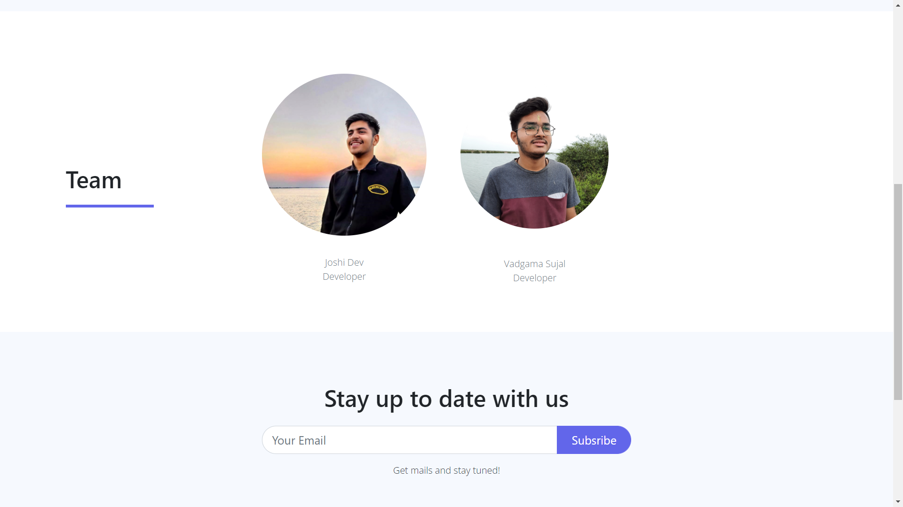

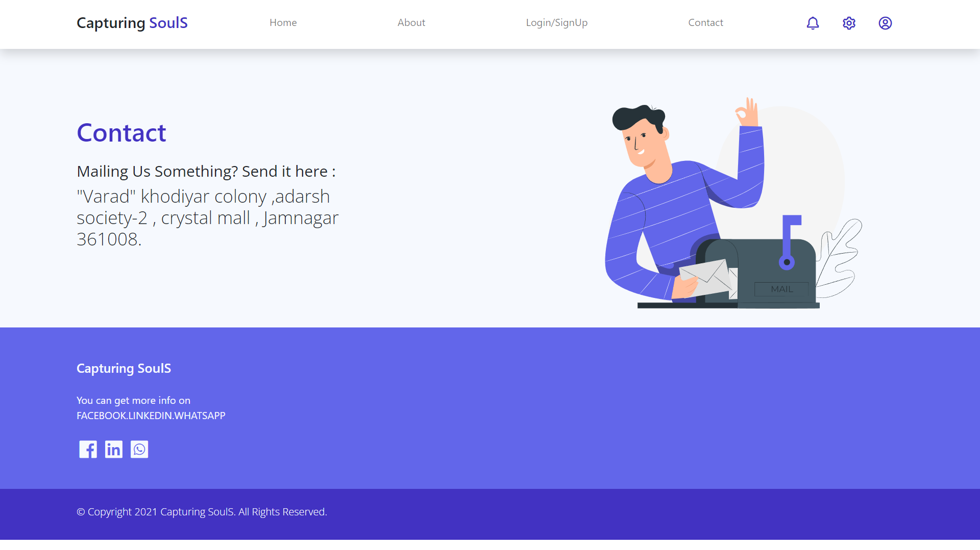

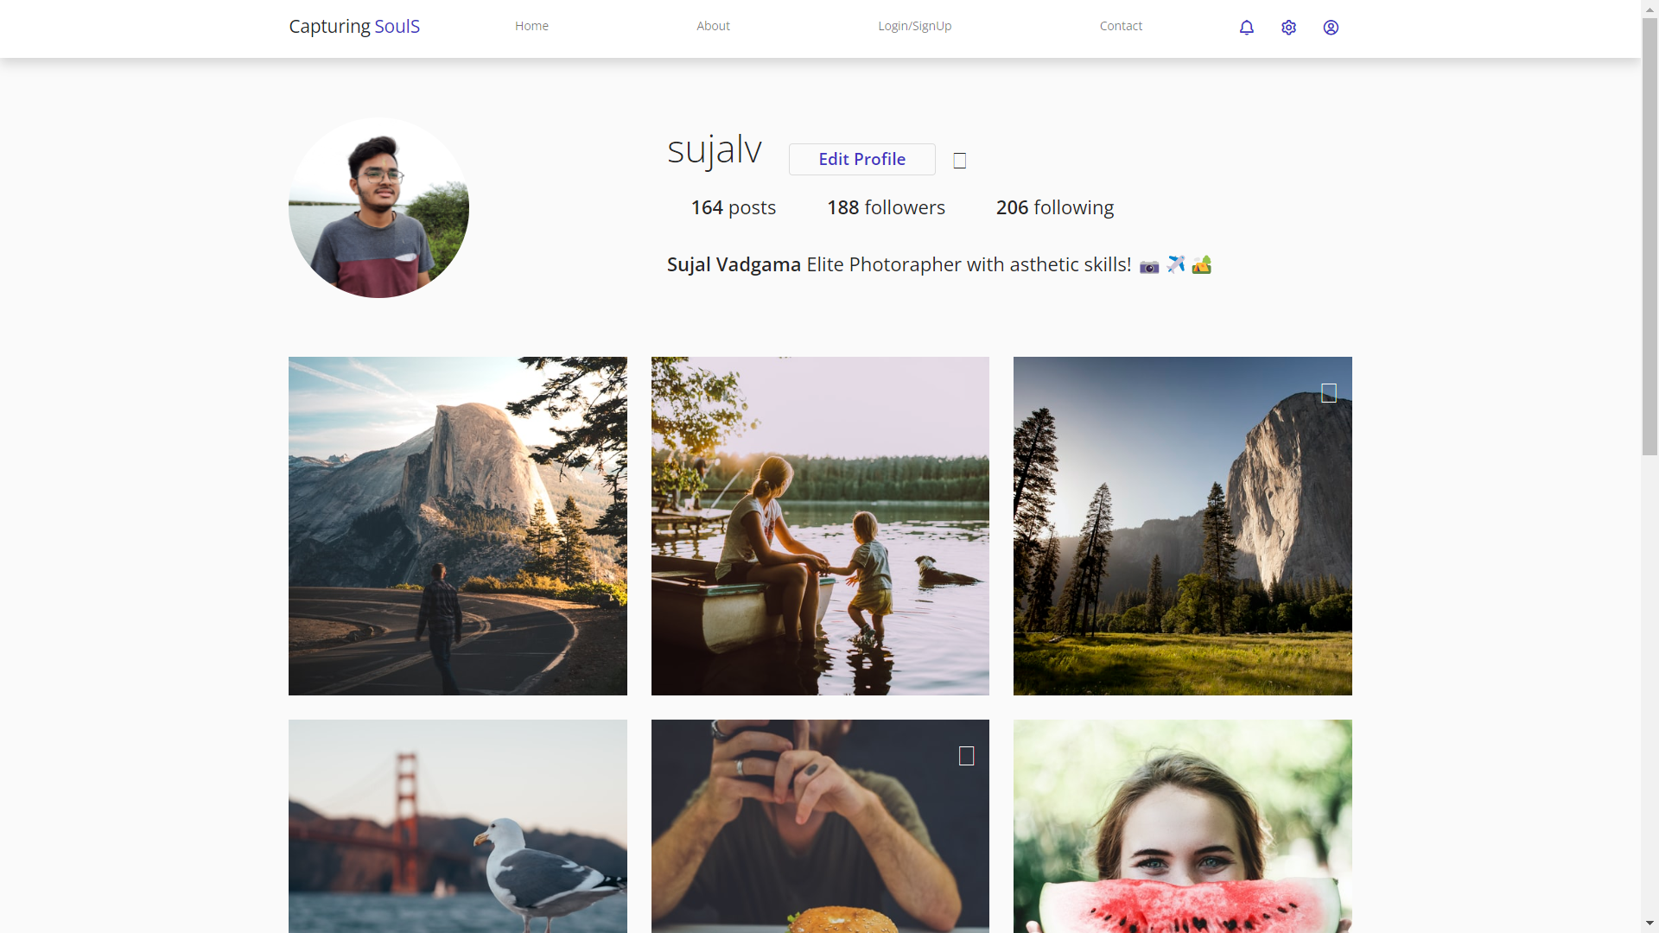

### 5.2 SAMPLE CODE

<!DOCTYPE html>

<html lang="en">

<body>

<nav id="main_nav" class="navbar navbar-expand-lg navbar-light bg-white shadow">

<div class="container d-flex justify-content-between align-items-center">

<a class="navbar-brand h1" href="index.php">

<span class="text-dark h4">Capturing</span> <span class="text-primary h4">SoulS</span>

</a>

<button class="navbar-toggler border-0" type="button" data-bs-toggle="collapse" data-bs-target="#navbar-toggler-success" aria-controls="navbarSupportedContent" aria-expanded="false" aria-label="Toggle navigation">

<span class="navbar-toggler-icon"></span>

</button>

<div class="align-self-center collapse navbar-collapse flex-fill d-lg-flex justify-content-lg-between" id="navbar-toggler-success">

<div class="flex-fill mx-xl-5 mb-2">

<ul class="nav navbar-nav d-flex justify-content-between mx-xl-5 text-center text-dark">

<li class="nav-item">

<a class="nav-link btn-outline-primary rounded-pill px-3" href="scroll.html">Home</a>

</li>

<li class="nav-item">

<a class="nav-link btn-outline-primary rounded-pill px-3" href="about.html">About</a>

</li>

<li class="nav-item">

<a class="nav-link btn-outline-primary rounded-pill px-3" href="pricing.html">Login/SignUp</a>

</li>

<li class="nav-item">

<a class="nav-link btn-outline-primary rounded-pill px-3" href="contact.html">Contact</a>

</li>

</ul>

</div>

<div class="navbar align-self-center d-flex">

<a class="nav-link" href="#"><i class='bx bx-bell bx-sm bx-tada-hover text-primary'></i></a>

<a class="nav-link" href="#"><i class='bx bx-cog bx-sm text-primary'></i></a>

<a class="nav-link" href="profile.html"><i class='bx bx-user-circle bx-sm text-primary'></i></a>

</div>

</div>

</div>

</nav>

<div class="banner-wrapper bg-light">

<div id="index_banner" class="banner-vertical-center-index container-fluid pt-5">

<!-- Start slider -->

<div id="carouselExampleIndicators" class="carousel slide" data-bs-ride="carousel">

<ol class="carousel-indicators">

<!-- <li data-bs-target="#carouselExampleIndicators" data-bs-slide-to="0" class="active"></li>

<li data-bs-target="#carouselExampleIndicators" data-bs-slide-to="1"></li>

<li data-bs-target="#carouselExampleIndicators" data-bs-slide-to="2"></li> -->

</ol>

<div class="carousel-inner">

<div class="carousel-item active">

<div class="py-5 row d-flex align-items-center">

<div class="banner-content col-lg-8 col-8 offset-2 m-lg-auto text-left py-5 pb-5">

<h1 class="banner-heading h1 text-secondary display-3 mb-0 pb-5 mx-0 px-0 light-300 typo-space-line">

Change your lens,

<br>Change your story

</h1>

<p class="banner-body text-muted py-3 mx-0 px-0">

<strong>Capturing SoulS</strong> is a Corporate photography contest website ,which creates anxiety between leading photographers <br>by their skills and passion ,which raises their rank in the contest.<br><br> We deploy

contest on the opening week day (Monday).As soon as participant post their pictures,they get results <br>on saturday eve.<br><br>

<strong>Wanna know how it works ?</strong> <a href="C:\Users\mrvad\Google Drive\capturing souls\registrationform.html" style="text-decoration: none;"> Register Now!</a>

</p>

<a class="banner-button btn rounded-pill btn-outline-primary btn-lg px-4" href="pricing.html" role="button">Get Started</a>

</div>

</div>

</div>

<div id="mybutton">

<a href="Uploadpage.html"><button class="feedback"><i class="fa fa-plus"></i></button></a>

</div>

</div>

</div>

</div>

</div>

</body>

## 6. CONCLUSION & FUTURE ENHANCEMENT

Overall Capturing Souls, is a photography-website that increases the hype of photography competition among the well-known photographers. And encourages the user for participating the contest by offering them cs points gained on winning the contest which could be redeemed in online shopping websites.

* A Subscription model will be introduced.
* Every week contest will be held.
* Every user could showcase their portfolio on their profile.
* Copyrights will be introduced for each photo and the users or viewers will pay rent for it.
* Capturing Souls will be available for all the platforms i.e. Android, IOS.